* Assignment 5-2 report
  + Tensorboard image
  + Simple description of what we did (Failed and wrote the process what we did for code)

We tried to implement assignment 5-2 with the reference code universe-starter-agent Github code. We tried to make codes from scratch but did not work well. Therefore, we copied codes from universe-starter-agent Github code and fitted with our assignment.

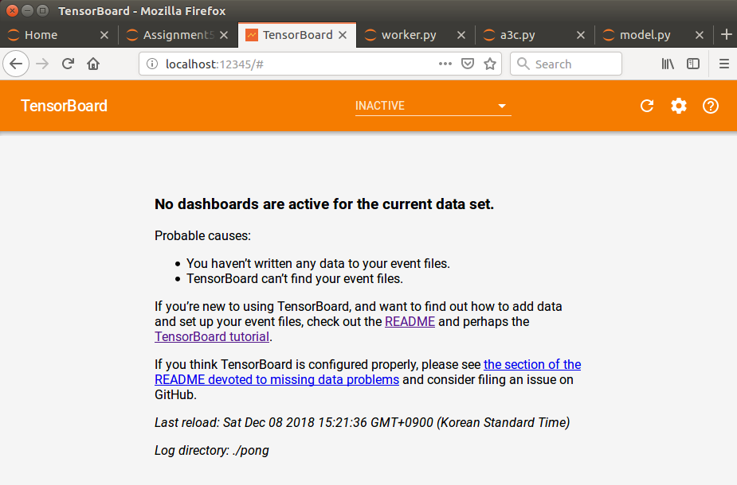We thought that at least the code from universe-starter-agent Github will work and show something on tensorboard. However, it showed nothing when we connect to localhost:12345 as below,

<The error message in tensorboard(localhost:12345)>

So we thought we set something wrong in the code or not installed packages properly.

We uninstall all things and installed again as description (install command) of Assignment5-2 gives, but still get above message, so we tried to google and find issues from universe-starter-agent for our problem and similar problems were in the issues of universe-starter-agent but couldn’t figure out our problem. Therefore, we sent an e-mail to TA for this problem. Before asking questions to TA, TA (Hyemi Jang) told us to use ‘tmux’ and use command ‘tmux attach –t a3c’ but we already set it as tmux and checked as workers are working we believed. So asked her again with below picture,

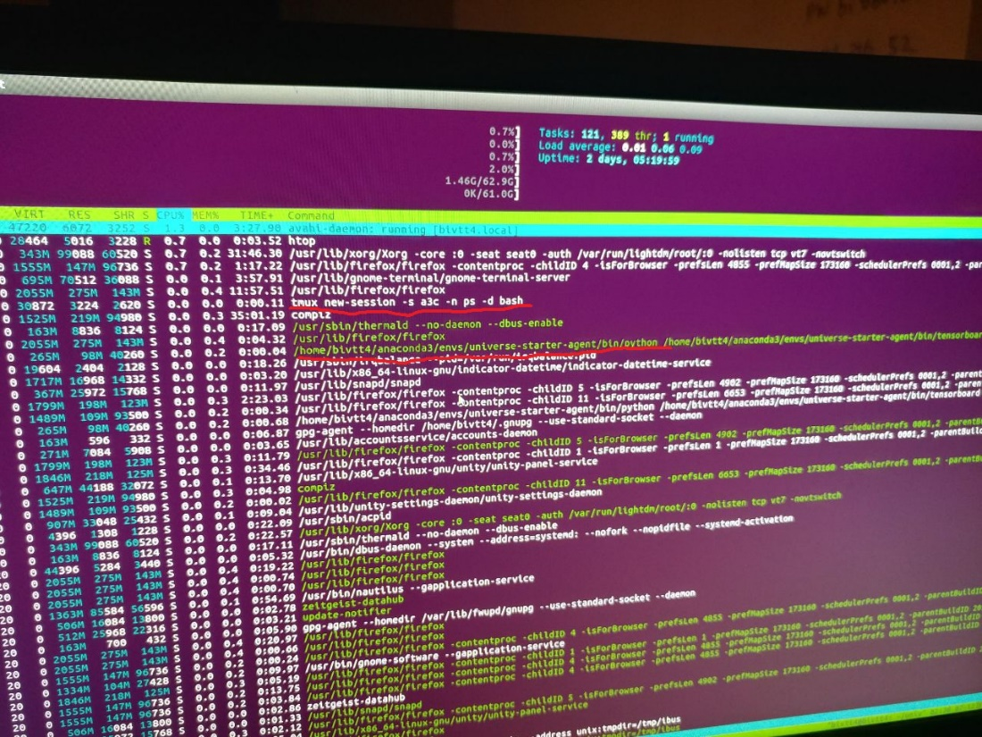

And she told us we need to know how to use tmux.

So as final project is also same due date as this assignment 5, we couldn’t finish this assignment 5-2.

Hope we can finish this assignment someday…